**GD&T Problem 5**

1. The focal point for each question is shown in red. Question 1, 2 and 3 are simpler and hence shown in with less attraction. Please go through the lecture slides and answer

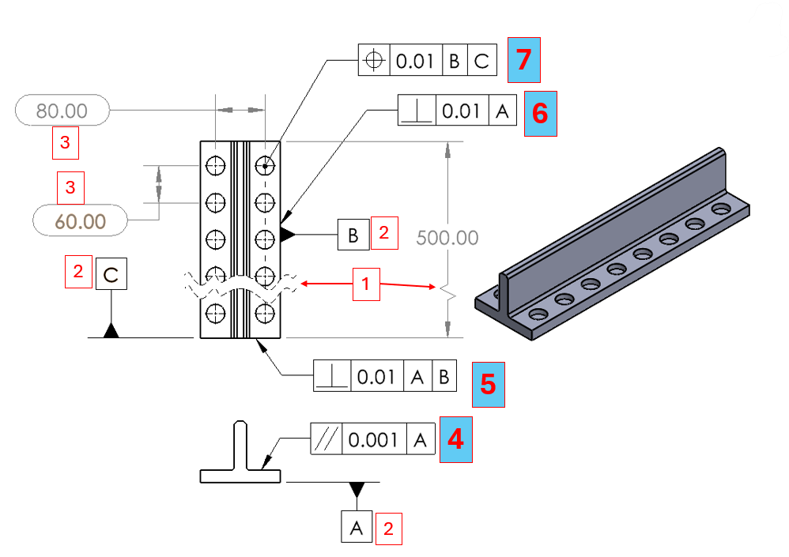

1. What does the pattern shown in represent? Why is it used?

The pattern means that the drawing is only showing a shortened version of the part. Since the part is quite long and repetitive, the entire length is not critical, only the dimensions between the holes are.

1. What do A, B and C in the box represent?

A, B, and C are datums, which are reference points that the machinist can use to align the part.

1. What do numbers 80 and 60 given inside the slotted pattern represent in GDT?

80 and 60 are marked for inspection. Since these are critical dimensions for the rest of the pattern, these must be as precise as possible.

1. What does the representation on 4 communicate to the machinist??

The surface pointed to must be parallel to the A datum within a tolerance of ±0.001.

1. What does the representation on 5 communicate to the machinist??

The surface pointed to must be perpendicular to both A and B datums within a tolerance of ±0.01.

1. What does the representation on 6 communicate to the machinist??

The surface pointed to must be perpendicular to datum A within a tolerance of ±0.01

1. What does the representation on 7 communicate to the machinist??

The position of the center of the hole must be in reference to datums B and C, and placed within a tolerance of ±0.01.

1. What is the common name for the representation shown in 4, 5,6 and 7?

Geometric Tolerances

* 1. What do the representations on each hole mean? Explain in your on terms, is there anything wrong with the representation of the dimensions shown inside the red circle. How will you fix it if there is something? Use dimensioning rules for reference

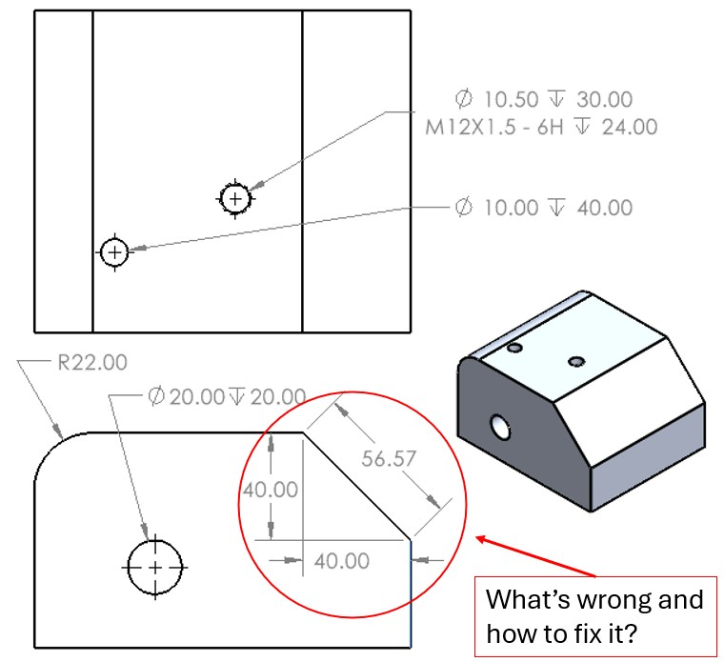

* 1. Make this part using hole wizard. Feel free to use appropriate dimensions for the block. **Use the extra space for notes**

The representations for the upper hole means the diameter of the hole is 10.5 with a depth of 30. The m12x1.5 represents the tap thread, and the -6h signifies the offset of the tap. The length of the tap goes for 24.

The second hole has a diameter of 10 and a depth of 40

The third hole has a diameter of 20 and a depth of 20

The dimensions are incorrect because the dimension extension lines cross for the 40.0 dimensions, and they are inside the model. Alternatively, the 56.57 can be removed because it can be calculated, and the left 40.0 can be moved outside to the right of the drawing, and the bottom 40.0 can be moved down below the drawing to prevent crossing of lines.

* 1. What do these holes made using the whole wizard mean to the machinist? Explain in your own words.

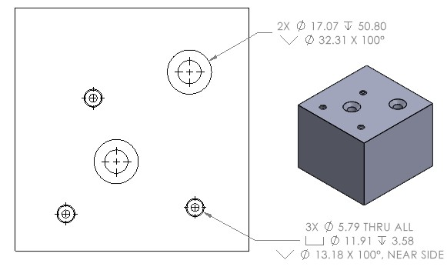

* 1. Make this part using hole wizard. Feel free to use appropriate dimensions for the block. **Use the extra space for notes**

The 3-hole annotation means that there are three holes, each with the following dimensions. They have a diameter of 5.79 that goes through all bodies. The counterbore has a diameter of 11.91 with a depth of 3.58. On top of the counterbore, a countersink is place with a diameter of 13.18 with an angle of 100 degrees, on the near side.

The 2-hole annotation means that there are two holes, each with the following dimensions. They have a diameter of 17.07 and a depth of 50.80. The hole has a countersink with a diameter of 32.31 at an angle of 100 degrees.

